WEEK 2- More Queries on insurance database

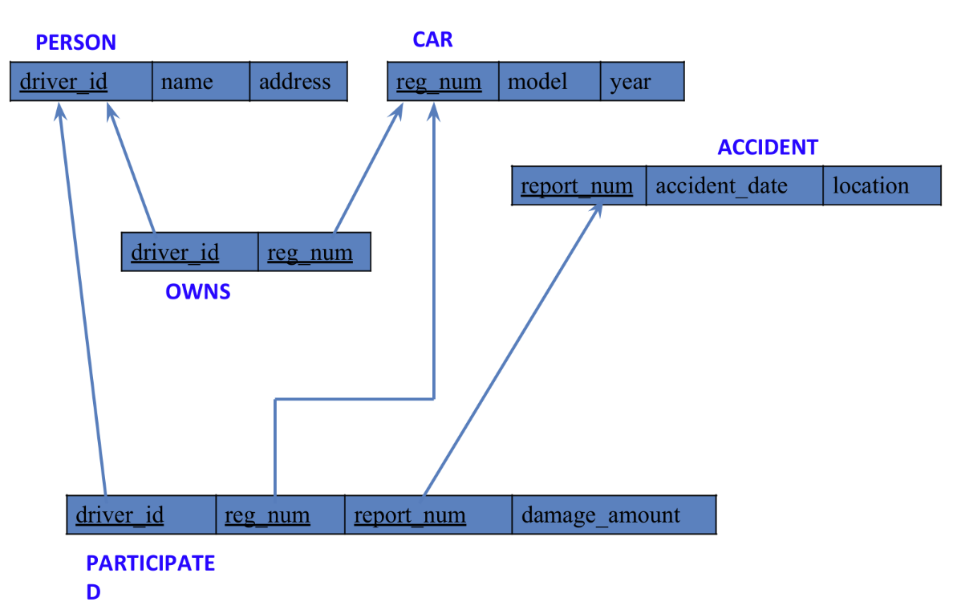

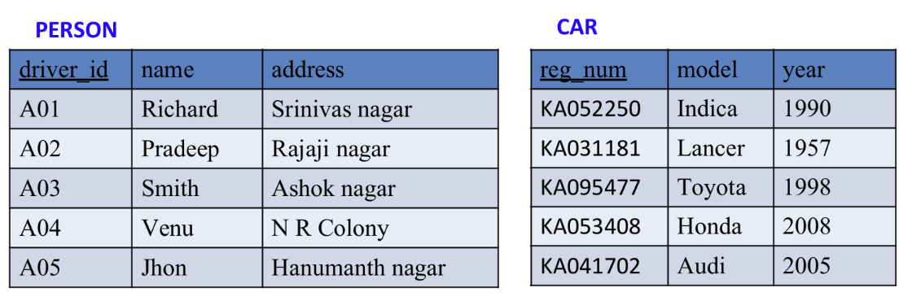

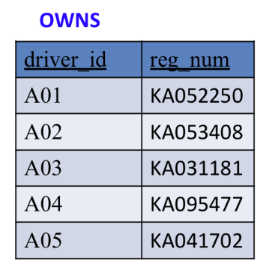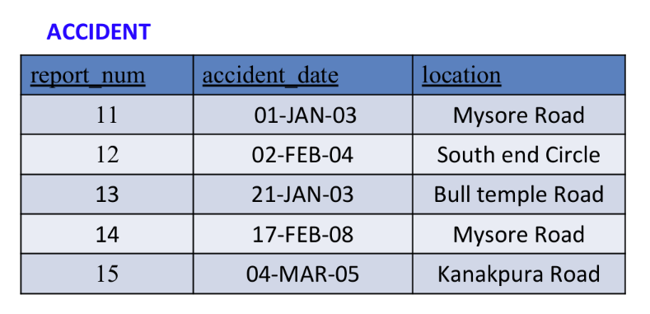

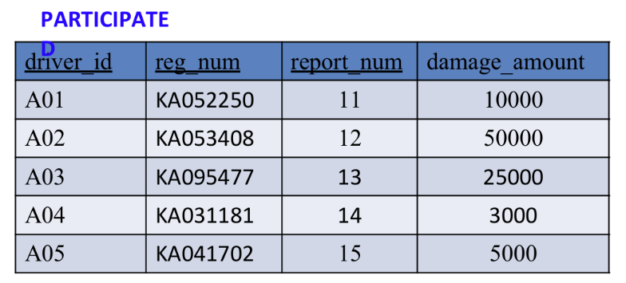

**QUERIES:**

* **Display the entire CAR relation in the ascending order of manufacturing year.**

select * from car order by year asc; 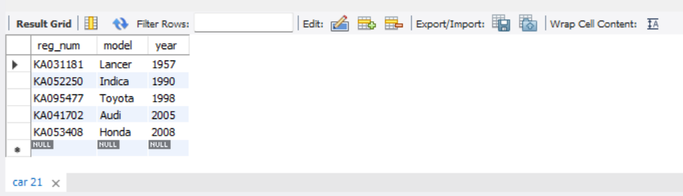

* **Find the number of accidents in which cars belonging to a specific model (example 'Lancer') were involved.**

select count(report_num)

from car c, participated p

where c.reg_num=p.reg_num and c.model='Lancer';

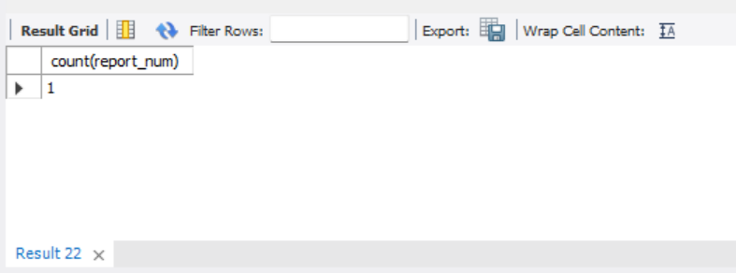

* **Find the total number of people who owned cars that were involved in accidents in 2008.**

select count(distinct driver_id) CNT

from participated a, accident b

where a.report_num=b.report_num and b.accident_date like '__08%';

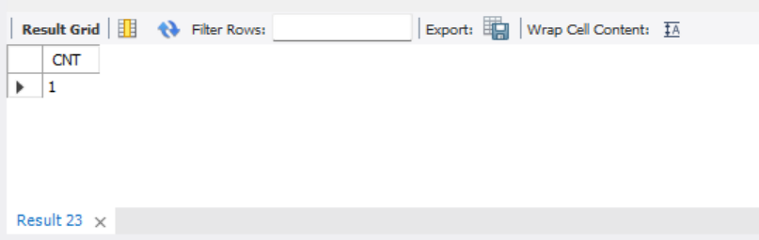

**TO DO:**

* **LIST THE ENTIRE PARTICIPATED RELATION IN THE DESCENDING ORDER OF DAMAGE AMOUNT.**

select * from participated order by damage_amount desc;

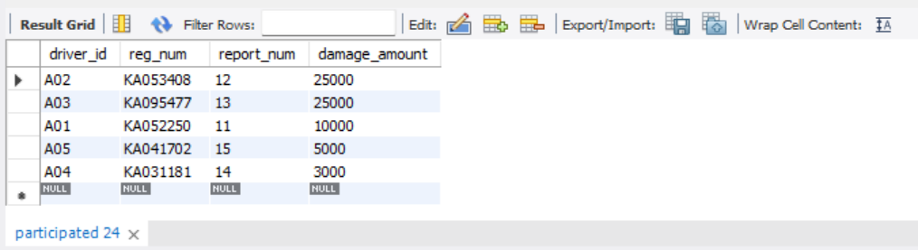

* **FIND THE AVERAGE DAMAGE AMOUNT**

SELECT AVG(damage_amount) from participated;

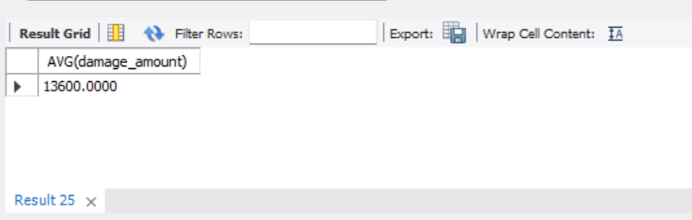

* **DELETE THE TUPLE WHOSE DAMAGE AMOUNT IS BELOW THE AVERAGE DAMAGE AMOUNT**

delete from participated

where damage_amount < (select p.damage_amount from(select AVG(damage_amount) as damage_amount FROM participated )p);



select * from participated;

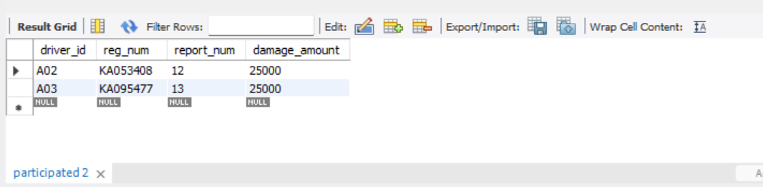

* **LIST THE NAME OF DRIVERS WHOSE DAMAGE IS GREATER THAN THE AVERAGE DAMAGE AMOUNT.**

select name from person p, participated part where p.driver_id=part.driver_id and damage_amount>(select AVG(damage_amount) FROM participated);

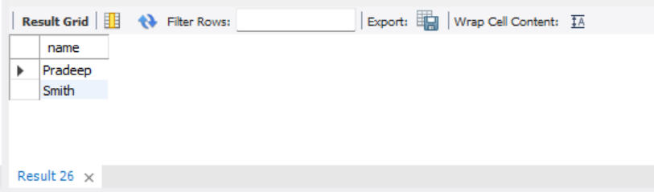

* **FIND MAXIMUM DAMAGE AMOUNT.**

select MAX(damage_amount) from participated;

